**YES!**

**NO!**

**BOO!**

**YEAH!**

**WHOA!**

**ANXIETY**

**TEAM**

**WORK**

**CABIN FEVER!!!**

**JINX! DAWM!**

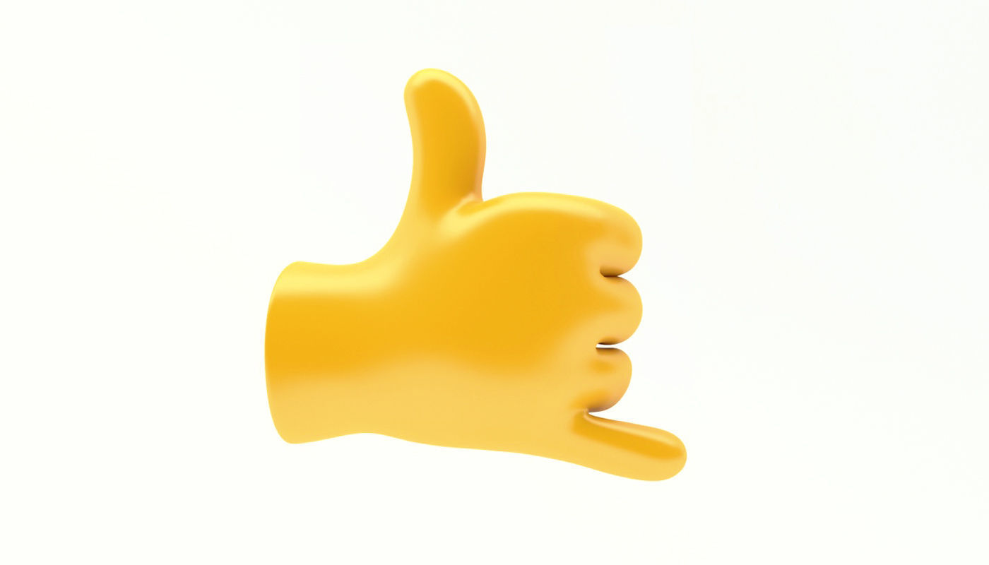**CALL**

**ME!**

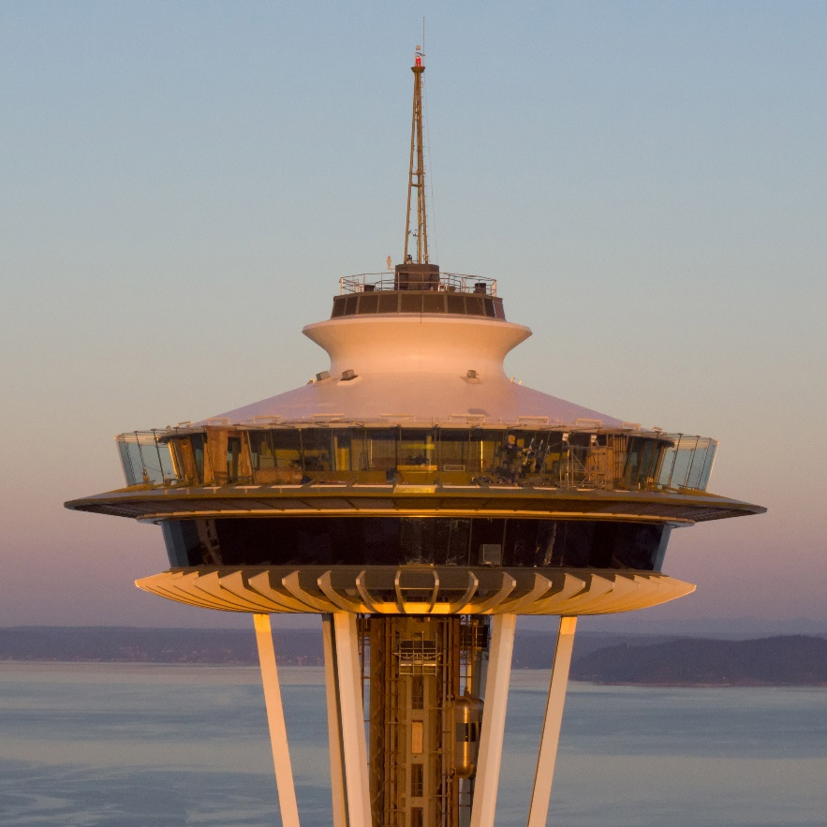**SEATTLE**

**YOU’RE ON MUTE!**

**CAN’T HEAR YOU!**

**CAN’T SEE YOU**

**WERD!**

**LOVE**

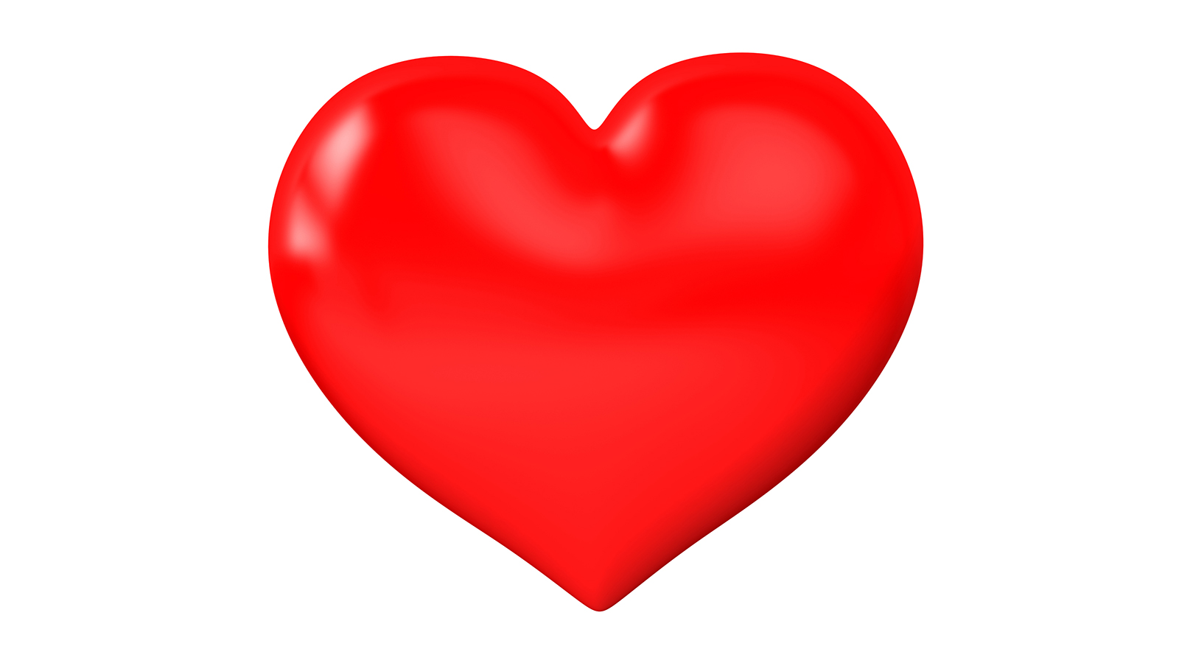

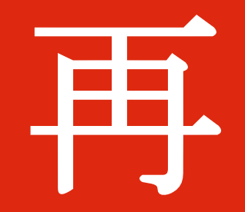

Zàijiàn

**PROBLEM**